[E106] Boil inlet valve

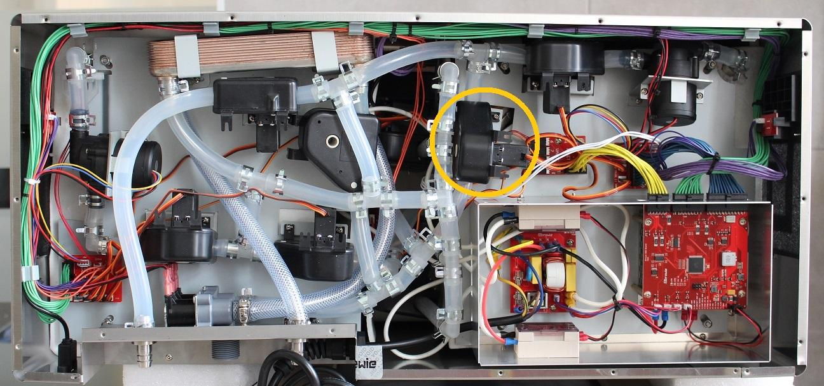

IMPORTANT: First, turn the machine on, enter the Service Interface and open all valves as valves can be removed only in open position.

Unscrew the indicated fastening screws of the valve and pull off the hose clamp and the silicone tube from the fitting. Remove the clamp to make way for the valve.

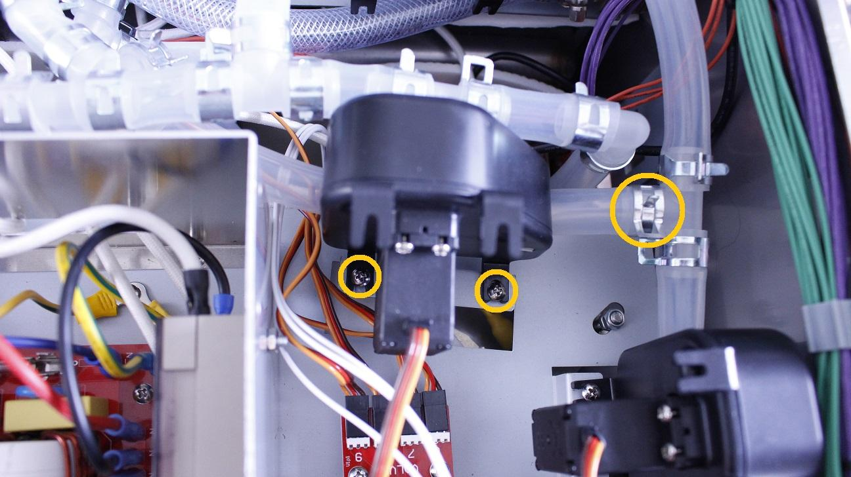

Disconnect the plug of the valve from the PCB panel.

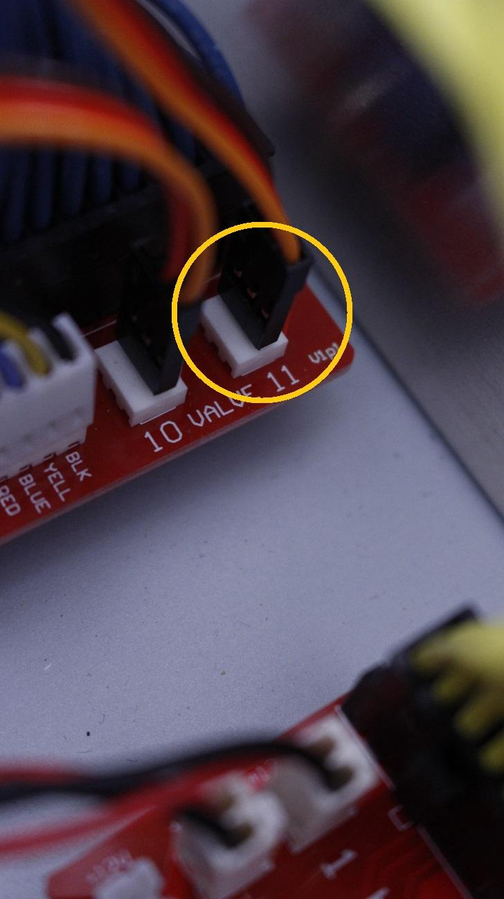

The valve can be removed now.

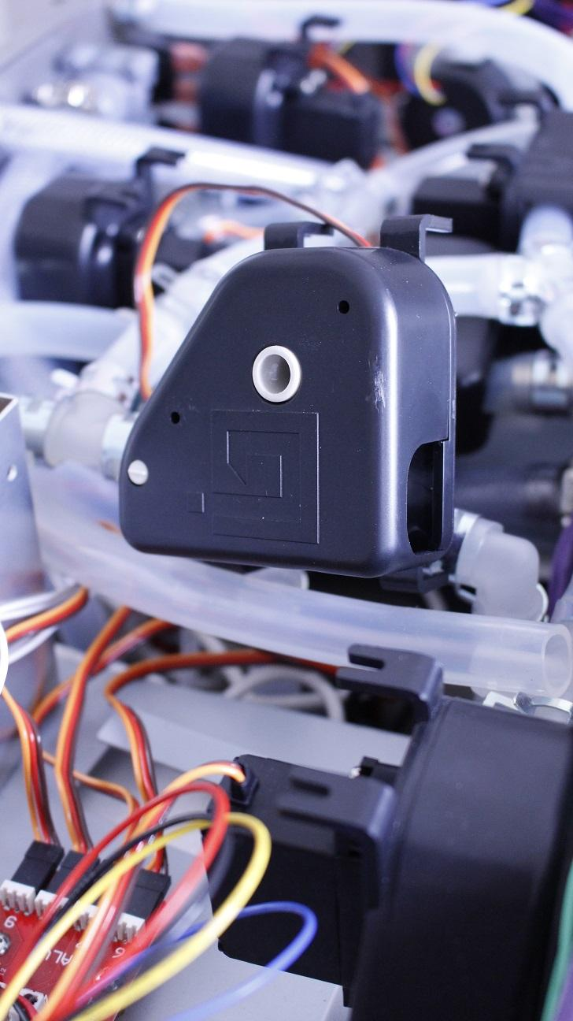

After removal of the valve, check if the inner wall of the silicone tube is clinged together. If it is clinged together, the valve replacement is unnecessary, only the inner walls have to be separated.

Reassemble consists of the same steps in reverse.